SKILL AND JOB RECOMMENDER

ASSIGNMENT -2

TEAM ID : PNT2022TMID42748

STUDENT NAME : JEYASURYA K

1)Create a user table with user email, user name ,roll no, password.

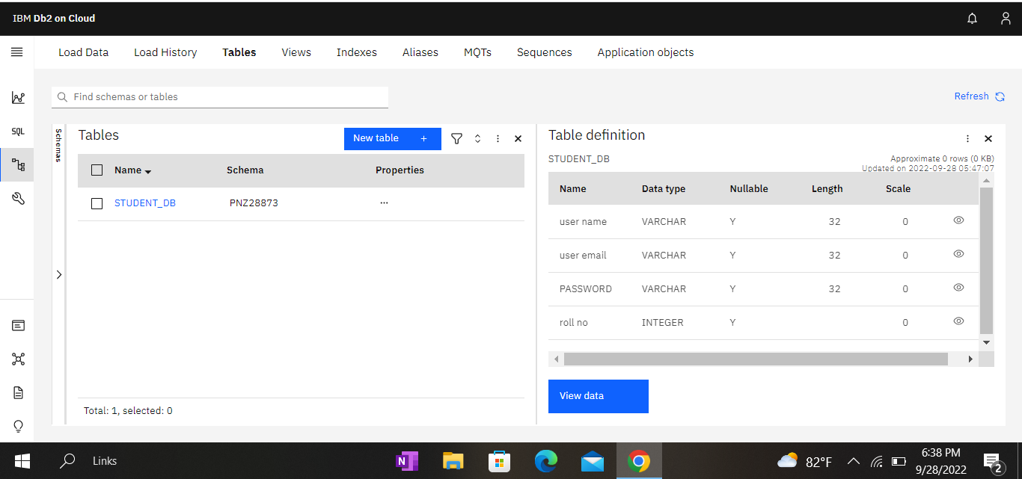

2) Perform update delete queries with user table

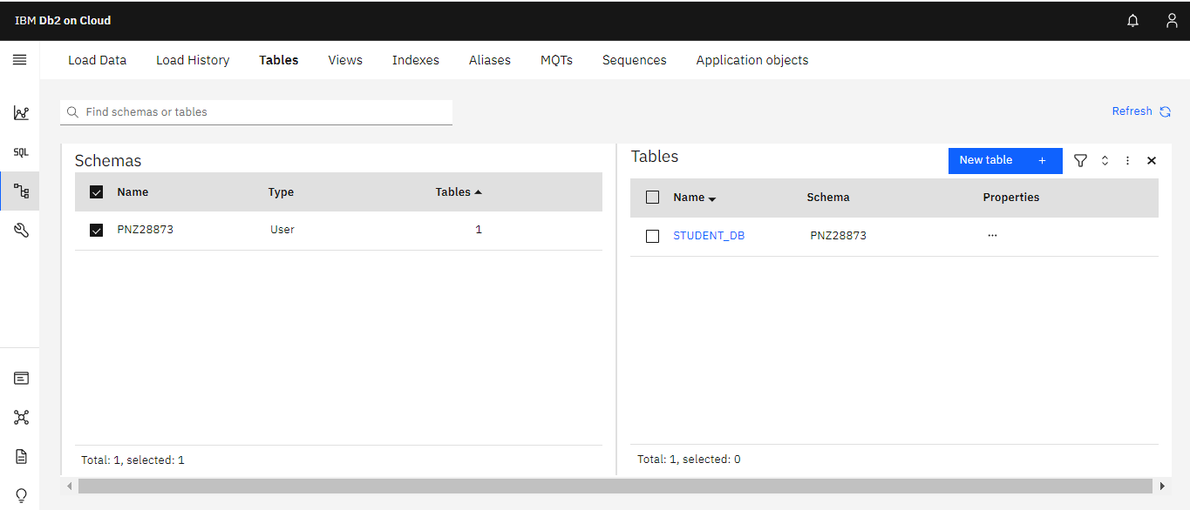

3) Connect python code with db2 (database)

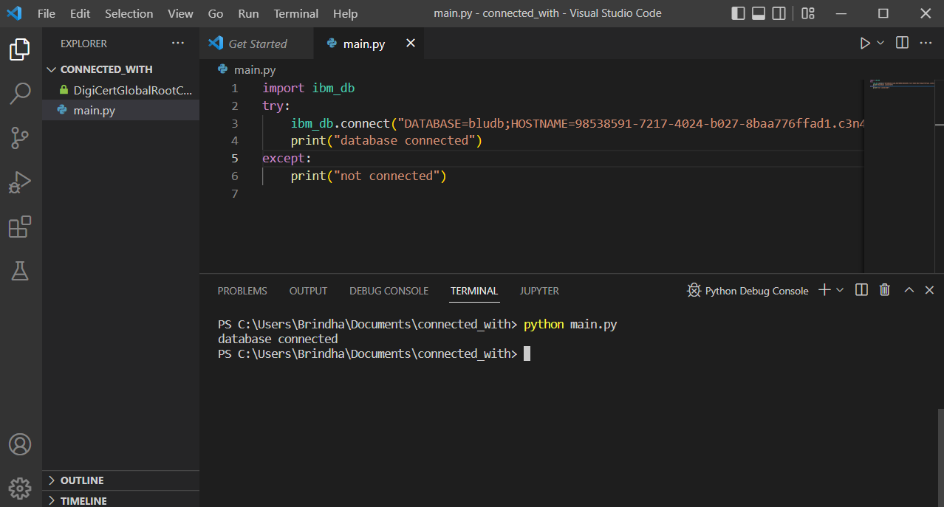

4) Create a flask app with registration page, login page and welcome page. By default load the registration page once the user enters all the fields, store the data in the database and navigate to the login page to authenticate user username and password. If the user is valid, show the welcome page.

a)Login page:

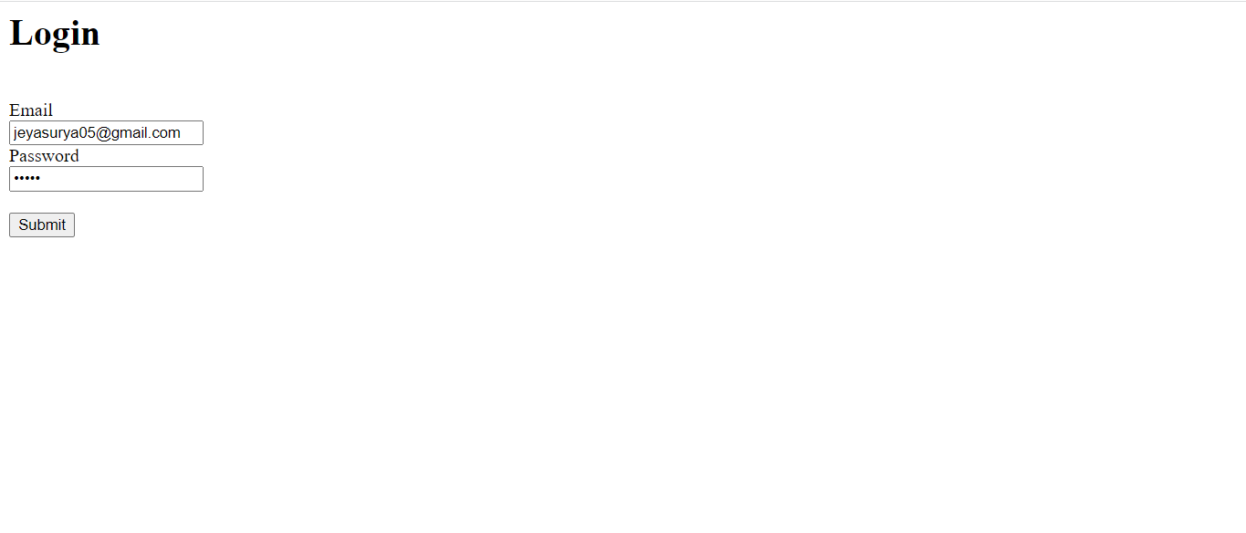

b)welcome page:



c) registration page:

